A000-Asia-China-Liangzhu-Jade-Headdress--Three-Post Holder--3400–2250 BCE

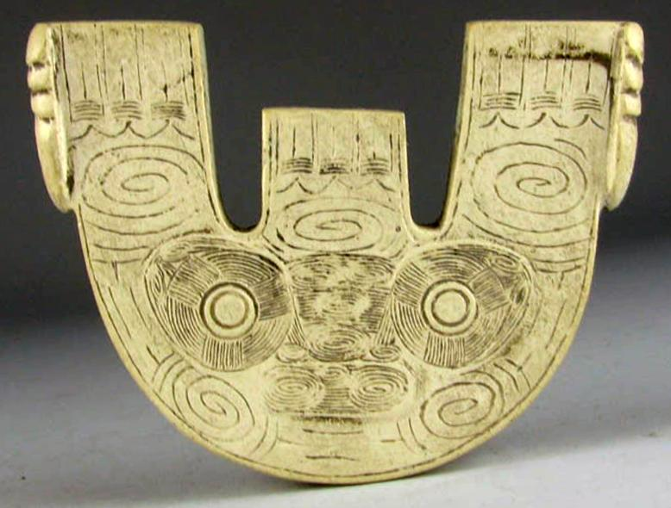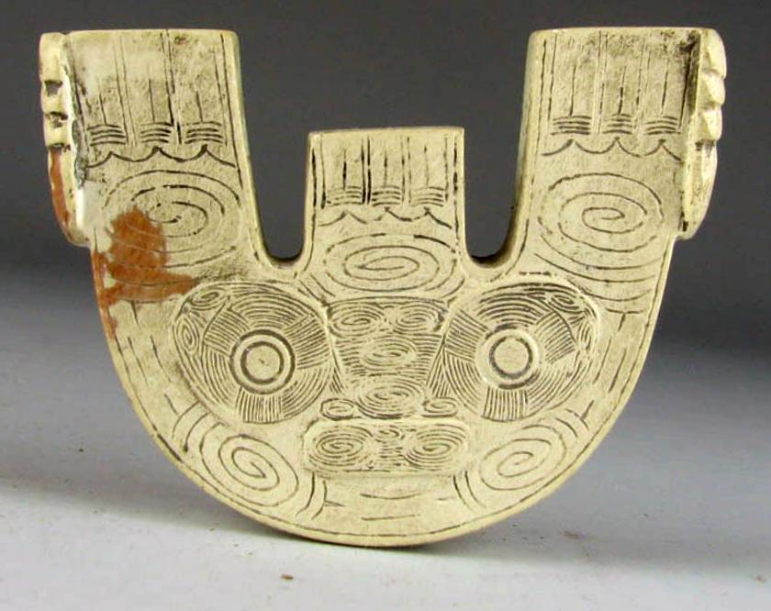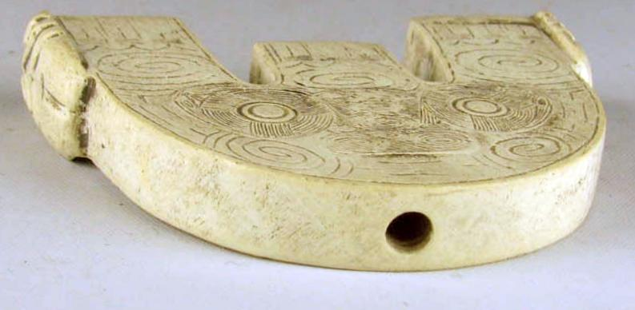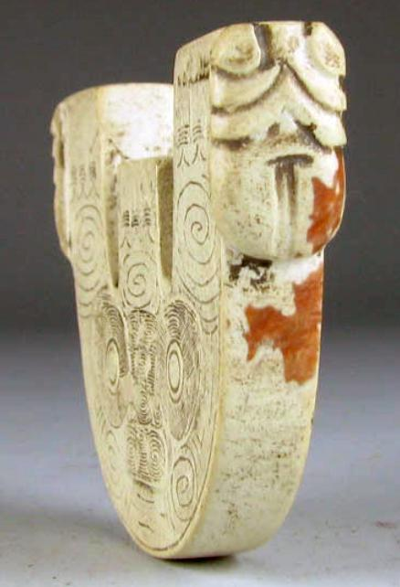

Figs. 1-4. Liangzhu-Jade-Headdress--Three-Post Holder--3400–2250 BCE

Case: 5

**Accession Number:**

**Formal Label:** Liangzhu-Jade-Headdress--Three-Post Holder--3400–2250 BCE

**Display Description:**

This Jade Headdress Three-Post Holderwas used in the headdress of shamans participating in rituals honoring numinous Heaven and the circulation of Earth around the immovable Pole Star. This circulation is symbolized by the feather motifs at the top of each of the posts. This movement around the Pole Star is indicated on this Three Post Holder by the spirals at each of the posts and below the anthropomorphic mask.

The evolution of the anthropomorphic mask appears to have undergone a transformation from that of a shamanic device of invoking animal powers to that of purely human ancestral powers by eliminating the animal panels and symbolizing the historical succession of generations purely abstractly.

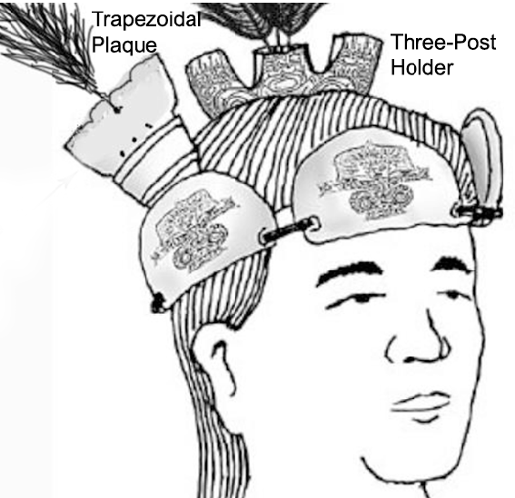

Fig. 5. Reconstruction of how the Three-Post Holder and the Trapezoidal Plaque were attached to combs. After Gu 2005.8:69; revised detail after Childs-Johnson 2009, fig.17, p. 352. The feathers indicate the movement of Earth around the Pole Star.

**LC Classification:** NK5750.2.A1

**Date or Time Horizon:** Liangzhu-Jade-Headdress-Three Post Holder-3400–2250 BCE BCE **Geographical Area:** Liangzhu culture, lower Yangzi River Valley

**Map:**

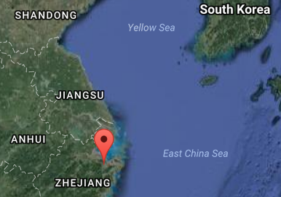

Fig. 6. Locationof Liangzhu site proper. Source: Google Earth

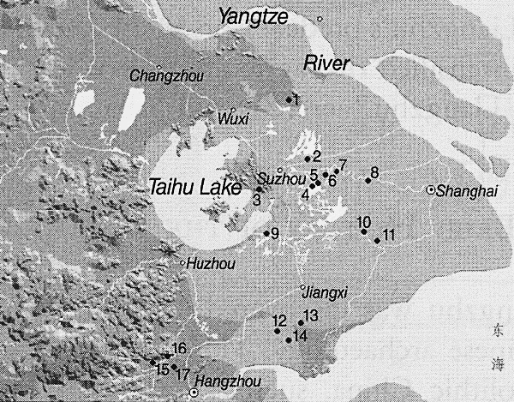

Fig. 7. Detail of Liangzhu site complex surrounding Taihu. After Zhou Ying 2007.

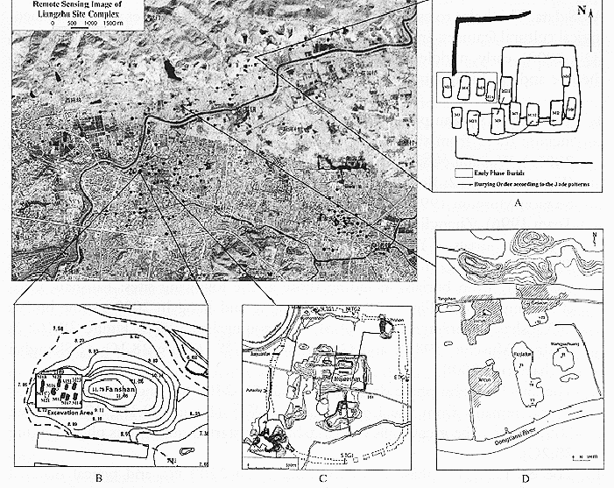

**Fig. 8.** Detail of Liangzhu site proper. After Zhou Ying 2007.

**GPS coordinates:**

Northeast corner: N 30°24'48", E 120°00'17"

Northwest corner: N 30°24'41", E 119°58'58"

Southeast corner: N 30°23'20", E 120 00'19"

Southwest corner: N 30°22'55", E 119°58'28"

**Cultural Affiliation:** Liangzhu culture, lower Yangzi River Valley, 3300-2250 BCE

**Medium:** jade

**Dimensions:** H 2 in, W 2.0 in, thickness 0.3 in.

**Weight:**

**Condition: original. The reddish stain** is thought to have been produced by minerals leaching from the decaying body into the nephrite during burial, a process that occurs in the first weeks after interment.

**Provenance:**

**Discussion:**

Liangzhu (3400–2250 BCE) in Yuhang County, Zhejiang, was a highly stratified Neolithic jade city-state in the Yangtze River delta where élites controlled a sphere of influence north to Shanxi and south to Guangdong. Jade and other expensive wares (such as silk, lacquerware, and ivory) characterized the social symbolism of Liangzhu élites which they used in ritual performances and dances as well as in grave goods..

DNA from Liangzhu culture sites that existed around Taihu Lake and the mouth of the Yangtze River exhibit high frequencies of Haplogroup O1 which was absent in other archaeological sites inland. Haplogroup O1 is common to modern Austronesians. The Taiwanese Aborigines/Taiwanese Austronesians (TAN) (O1) probably came from those Liangzhu Austronesians (LAN) who were displaced from Southern China by the demise of the LAN perhaps induced by the meteor of ca 4500 BCE that struck at the location of Taihu Lake. LAN culture sites that existed around Taihu Lake and the mouth of the Yangtze River were at risk from such an event, and by ca 4200 BP LAN succumbed to a series extreme floods that interrupted the cultural layers with intrusions of mud and sand.

**References:**

Biot, Jean Baptiste. 1851. *Le Tcheou-li: ou, Rites des Tcheou*. Paris: Imprimerie nationale, 1851. 3v.

Chang, K.C., Xu, P. and Lu, L. 2005. *The formation of Chinese civilization: an archaeological perspective*. New Haven: Yale University Press.

Childs-Johnson, Elizabeth. 1988. *Ritual and Power: Jades of Ancient China*. New York: China House Gallery, China Institute in America.

Childs-Johnson, Elizabeth. 2009. The Art of working Jade and the rise of civilization in China. In Elizabeth Childs-Johnson, *Early Chinese jades in American Museums.* Beijing: The Science Press, China Science and Technology Publishing and Media Co., Ltd., 2009, pp. 291-393.

Gu Fang. 2005. *Complete collection of unearthed jades in China*. 15 v. Beijing: China Science and Technology Publishing and Media Co., Ltd.

Hayashi, Minao. 林巳奈夫. 1991. *Chūgoku kogyoku no kenkyū*. 中國古玉の研究. Tōkyō : Yoshikawa Kōbunkan; 東京 : 吉川弘文館, 1991.



Hayashi, Mineo. 1990. “On the Chinese Neolithic jade Tsung/Cong,” *Artibus Asiae*, 50(1/2):5-22.

Hayashi, Mineo. 1973. *Toyo Gakuho* [Journal of the Research Dept. of the Toyo Bunko] 45:1-57.

Laufer, Berthold. 1912. *Jade a study in Chinese archaeology and religion*. Field Museum of Natural History, Publication 154, Anthroplogical series, vol. X. Chicago.

Li, Hui; Huang, Ying; Mustavich, Laura F.; Zhang, Fan; Tan, Jing-Ze; Wang, ling-E; Qian, Ji; Gao, Meng-He; Jin, Li. 2007. "Y chromosomes of prehistoric people along the Yangtze River," Human Genetics **122**: 383–388.

Lu Wenbao. 1998. Cong-shaped bead. In Liangzhu Culture Museum, ed., The dawn of Chinese civilization: Jades of the Liangzhu culture. Hong Kong: Liangzhu Culture Museum and The Art Museum, The Chinese University of Hong Kong.

Wu, Li. 2014. "Holocene environmental change and its impacts on human settlement in the Shanghai Area, East China," Catena. **114**: 78–89

Zhang, Chia; Hsiao-Chun, Hung. 2008. "The Neolithic of Southern China–Origin, Development, and Dispersal,"Asian Perspectives. **47**:2, 309–310.

|  |
| --- |
| Zhou Ying. 2007. 东方文明的曙光: 良渚遗址与良渚文化 = **Dong fang wen ming de shu guang : Liang zhu yi zhi yu liang zhu wen hua =** *The Dawn of the Oriental Civilization: Liangzhu site and Liangzhu culture*. Beijing: China Intercontinental Press. |